Handguard Removal Tool
by Doug Paul

Copyright © 2002 Builders Squad Notebook All rights reserved
Used with permission of the author

If you own an AR15 and have ever had reason to remove its front handguards (as you should every now and then just to clean all the "gunk" out from underneath 'em), then you know what a frustrating chore it can be to try to do this by yourself. Unless you happen to have been born with four hands, it's an extremely difficult task, and in some cases, is darn near impossible. Brownells sells a nifty little tool that greatly simplifies the handguard removal process. This tool really works great and turns a finger fumbling four-handed operation into a quick and easy two-handed ten-second process.

AR-15/M16 HANDGUARD REMOVAL TOOL
As described on their website - Handguard Removal. Takes all the fumbling, grumbling and frustration out of installing or removing AR-15 handguards. Easy-to-use, just hook tool into mag well and push down on the handles. Pushes the delta ring straight down, allows both handguards to be removed in just seconds. SPECS: Steel, rubber handles, matte finish, black. 11¼" (28.6cm) long. Fits AR-15 A1, A2, M-16 and AR-10. Stock No. 100-000-438 Handguard Tool $24.95”
Now if you've got a spare $25 bucks (plus shipping) that's burnin' a hole in your pocket and you feel like donating it to the fine folks at Brownells, then read no further. Just click on the link and order ya' one of these handy little gizmos. You'll wonder how you ever got along without it.
On the other hand, if you're like most of us "Garage Gunsmiths", you can probably think of all sorts of better uses for that $25 bucks. Small items such as scope bases, finishing materials, spare parts, or even just "more beer" come readily to mind. So lets see if we can make ourselves one of these handy little tools and save that $25 bucks to spend on other more "worthy" items.
The tool that Brownells sells is so simple, it actually makes you wonder how they can sleep at night trying to charge twenty-five bucks for it in the first place. All the heck it is, is a piece of bent steel rod with a little steel "L" bracket welded on one end and a couple pieces of rubber tubing slipped over the handle ends. Guess they figure they'll sell it to all those folks out there who either don't own a welding rig or, if they do own one, don't know how to use it. And maybe that's exactly who buys the things. I don't know.
Anyway, let's see if we can figure out how to make a "no welding required" version of the thing. Here's a list of everything that you're gonna need. This "materials list" below is actually enough "raw-stock" to make two of these tools. (You can give the other one to that shootin' buddy that you owe a favor to.) I've listed the prices of these items for those that might have to go out and buy the stuff from Leowes or Home Depot. All the materials I used came out of my "Junk and Left-Overs" bin so my total cost ended up being a big fat $0.00.
- A four foot (48") long piece of 1/4" diameter round steel stock ($2.93 in the "fastener" department)
- A three foot (36") long piece of 1/4" ID rubber hose (.63¢ in the "plumbing" department)
- A one foot (12") long piece of 1/2" ID rubber hose (.28¢ in the "plumbing" department)
- A propane torch (Surely you already own a propane torch!)
- A vise (doesn't have to be huge, but bigger is always better)
- A pair of large channel-lock pliers
The length of the 1/4" steel rod isn't really all that critical (actually, none of this is really critical). The tools pictured here were made out of 24" long sections of 1/4" diameter rod and they worked great. A 26" or 28" long piece might have been just a tad bit better, but the 24" worked fine. Got all the materials together? Fire up that torch and let's get going.
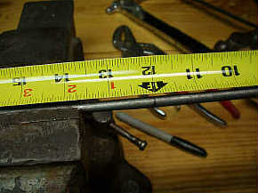 | 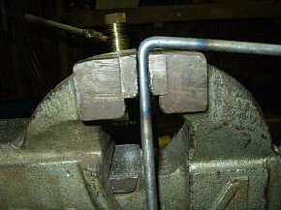 | 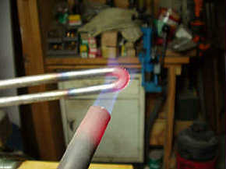
Measure the rods length and mark its center with a light file cut. Set the vise jaws so the rod will just slip between them and holding one end of the rod with a rag or glove, heat the center of the rod till it glows bright red. (Don't heat it while clamped in the vise or the jaws will draw off too much heat.) | When the center area around your mark glows red, slip the rod in between the vise jaws so that your center point mark is right at the top of the jaws. Grab the top end of the rod and make a sharp 90° bend right at the center of the rod. | Slide the rod out of the vise, apply more heat with the torch at the center bend until it again glows bright red. Holding each end of the rod, keep bending it until you have made a complete 180° "U" shaped bend in the center of the rod.

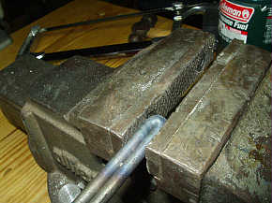 | 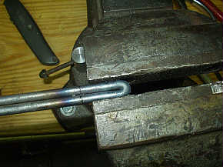 | 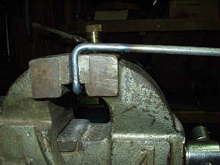
Measure the rods length and mark its center with a light file cut. Set the vise jaws so the rod will just slip between them and holding one end of the rod with a rag or glove, heat the center of the rod till it glows bright red. (Don't heat it while clamped in the vise or the jaws will draw off too much heat.) | When the center area around your mark glows red, slip the rod in between the vise jaws so that your center point mark is right at the top of the jaws. Grab the top end of the rod and make a sharp 90° bend right at the center of the rod. | When the center area around your mark glows red, slip the rod in between the vise jaws so that your center point mark is right at the top of the jaws. Grab the top end of the rod and make a sharp 90° bend right at the center of the rod.

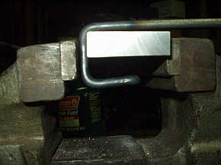 | 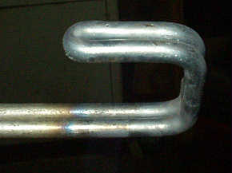 | 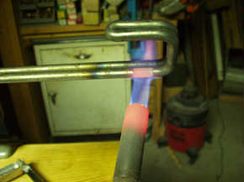
Mark a spot on both rods about 1 ¼” up from the firsts 90° bend, heat this area and make another sharp 90° bend in both rods at this point | This bend is made in both rods at the same point and in the same direction as the first 90° bend in order to form a square shape hook as in the picture | Take it back to the torch and bring both rod legs up to red hot about ½” up from the bottom bend of the newly formed hook.

Depending on the exact size and configuration or your vise, making this next "inside" bend might require a bit of thought and the placement of some sort of "scrap metal" piece between the vise jaws to act as a "bending blocks" to support the rod as it is bent. I only had to do this for the one bend that is shown next, and all I used was a small rectangular block of aluminum as a spacer.

Clamp the back side of the hook about 1/2" deep in the vise jaws and bend each leg "out" 90° away from the hook. Make this bend sharp and keep the rods "in-line" with each other. | Make a light file mark on each leg exactly 1" out from the "center" of the crease between the two rods where they come together to form the upper part of the square hook. | Clamp the hook in the vise with the legs overhanging the jaw ends. Heat each leg red hot at the mark, grab the leg with the channel-locks, just "inside" of the mark, and bend the leg "up" 90° making sure both legs remain "in-line" with each other.

And there we are. All "bent-out-of-shape" as it were. Quench the heated rod in cool water and apply some light oil to it to keep it from rusting. Cut a couple of pieces of the 1/4" rubber hose to match the length of the remaining straight ends of the two rods and slip the rubber tubing over the two "handles". Cut a 1" long piece of the 1/2" rubber hose and slip it over the bottom leg of the square "hook".
That's it. We're done. Total cost (mine anyway) - $0.00. (Well, actually, I suppose I might have used thirty cents worth of propane.)
Total time - If all this "bending" business took you more than ten minutes, you're doin' something wrong.

Does it work? You bet it works. Slick as a whistle. Here's a shot of the tool in use. Slide the rubber covered "handles" around the delta ring, with the rubber covered end of the "hook" running up into the magazine well from the bottom. With one hand, squeeze the two handles together around the delta ring and pull them down towards the butt of the rifle. This action pulls the delta ring back and the handguards can be easily removed with the other hand.
Simple. Works every time and works just as easily for replacing the handguards when you're through cleaning. Works with either the slope sided delta ring or the early flat sided ring. Metal or plastic. A simple little fifteen minute "project" that'll save you countless headaches, bruised fingers, and mangled finger nails. And . . . best part of all . . . . you saved $25 bucks.

