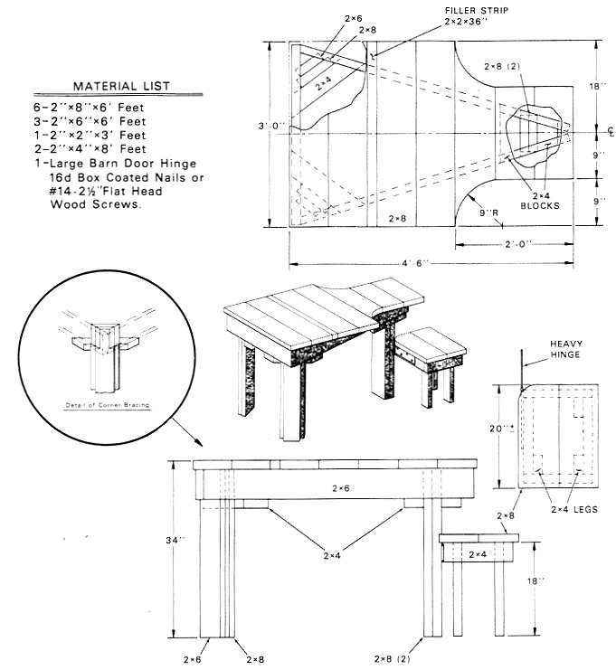

BENCH-REST CONSTRUCTION

These plans were published in the January 1994 American Rifleman

MATERIAL LIST

6 - 2"x8"x6' Feet
3 - 2-x6-x6' Feet
1 - 2"=2"x3' Feet
2 - 2"x4"x8' Feet
1 - Large Barn Door Hinge
1 box - 6d Box Coated Nails or #14-2 ½"Flat Head Wood Screws.

The ground on which the bench is to be placed should be level. The legs should be constructed of pressure-treated timber and sunk into the ground or set in concrete.

To locate the legs, establish a center line direct to the target. Place the two front legs with their centers about 11" to the right and left of this center line, and the rear leg directly on the center line with its center about 3 ft. 8½" behind a center line connecting the two front legs. Using three 2"x8" planks, spike or screw these to the outer edges of the three legs to connect them. The tops of these planks must be even with the tops of the legs and level.

The top of the triangle thus formed provides the base on which to fasten the 1¾"- or 2"-thick top planks, planed smooth. The shape and dimensions of this top are shown in the plans. Make the top level from side to side and front to back, even if the site of the targets is above or below the bench site.

Provide two solid benches for shooters to sit on, one for a right-handed shooter and one for a left-hander. These can be made by planting two sturdy posts in the ground and spiking a 10" plank on top. The seat should be about 18" above the ground and about 2-ft. long. An optional hinged seat is also shown, which can be moved for comfort.

